Negative results:

The first solution had been made was successful but It had not satisfied the design and solution requirements so, it had been changed to the current solution.

The solution was to use wash the wheels of the wheelchair with water before entering house Using Arduino, water pumps, water containers and nozzles.

Circuit:

The Arduino was connected with the relay module to control the water pumps. The water pumps were connected to water tanks. When the user is in front of the home, he well presses on the button of the device to makes the water pumps work and pumps water through the nozzles to wash the wheels.

Materials used:

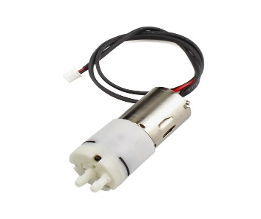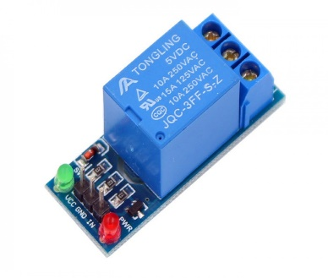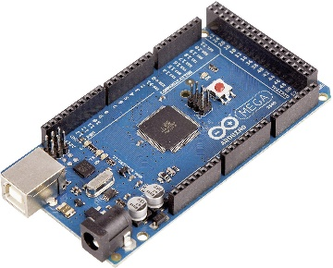

Figure Water pump

Figure 2 Relay module

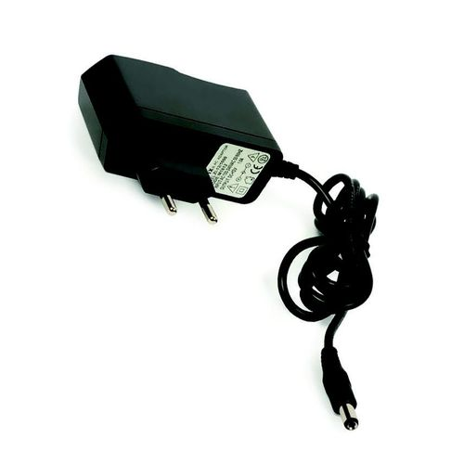

Figure Adapter

Figure Water container

Figure Arduino Mega

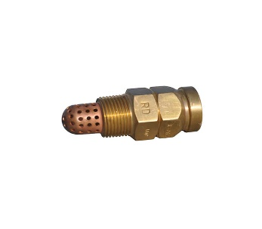

Figure Nozzle

Code:

The code was written using c Arduino using Arduino IDE

Mechanism:

1. The Arduino is the main microcontroller of the project
2. The Arduino takes the signal from the push button
3. Once the Arduino received the signal from the push button, it turns on the water pump
4. The water pumps push through the hoses
5. Nozzles are fixed at the end of the hoses to make the water spread out

Disadvantages of the project:

1. low efficiency as the water only reaches small part of the wheel.
2. High cost in compared to the low efficiency
3. The devices occupy wide area because of using two big water containers, one for each pump.